Cell Sorting- Things to Consider
Quik tips
- The droplet containing the cell is charged and can be attracted to the charge on the plastic. This results in the droplet hitting the side of the tube wall, and the cell dying as the small volume of liquid evaporates. To prevent this, pre-coat the tube with protein (FBS/BSA) containing buffer to neutralize the plastic charge and use polypropylene collection tubes.

- Cells are going to be traveling in buffered saline. This is not conducive for keeping cells alive for long periods of time. To improve recovery, ensure the catch buffer (1/3 vol. of collection tube) has protein (BSA/FBS) (10-50%).

- If sorting into media, make sure the media is HEPES buffered. Buffers like RPMI are formulated to buffer in the CO2 atmosphere of an incubator and don’t buffer well in our normal atmosphere. This is especially true for plate sorting!

- Know how the cells respond to temperature differences. Some cells do not like to be kept cold and will die quickly if sorted into 4-degree Celsius buffer. The collection chamber can be controlled for temperature.

- Adherent cells are commonly disassociated with trypsin with FBS used to neutralize the trypsin. However FBS can also add back all of the components that cells need to re-adhere causing clumping. Try soybean trypsin inhibitor instead.

- A clogged nozzle will take a long time to re-stabilize. Just before sorting pass the cells through an appropriate sized filter to remove clumps and debris. Also consider looking at the cells under a microscope to ensure that there are no clumps prior to sorting. If a sample contains visible clumps it will not pass through the sort nozzle!

- Include a viability dye to help eliminate dead cells.

- When trying to define a cell population, include both positive and negative markers in your antibody panel to ensure the cells are what they are supposed to be. Dump channels, can also help to identify unwanted populations.

- Know the cell count at the time the cells are going onto the sorter – NOT from when you first began preparing them.

- Since an optimal sort speed is typically ¼ the droplet generation frequency, over concentrating the cells will reduce purity. Bring some dilution buffer with you just in case the cells are too concentrated.

- The higher the threshold, the easier it is to visualize the specific cell population. But this does not eliminate the fact that debris and junk are still present within the cell population you’re visualizing. It just means that the cytometer is ignoring it.
Whatever the cytometer ignores will end up in the final sorted population.
For example, a “pure” population of sorted mature B cells may contain a lot of red blood cells if they have not been removed!

- Anything can be sorted as long as it’s big enough to be detected by the instrument (this depends on the instrument, but >0.5 μm is reasonable for many instruments) and small enough to fit through the nozzle tip at the end of the flow cell without clogging it or causing side stream instability (usually < 1/5 the size of the nozzle tip). Common nozzle sizes are 70/100/130μm.

- Cells that have just come out of the nozzle are fragile. Allow them time to recover. Cell sorters are usually housed in air-conditioned rooms wherein the room temperature hovers between 19-22°C. Your cells are not used to being cold so let them equilibrate to 37°C before manipulating them.
- Use tight sorting gates with biexponential plots along with low threshold (see point 11).

Principles of cell sorting
Droplet charging occurs in the nozzle and is applied to the entire connected stream rather than individual droplets. The point at which the droplet is charged (droplet break-off) is downstream of where the charge is applied.
By calculating the “drop delay” (time between laser interrogation point and droplet break-off.) the system can determine how long the system waits before applying a charge as a particle is detected.
The application of positive and negative charge at varying amounts will allow the charge plates to deflect the droplet containing the cell into the appropriate tube.
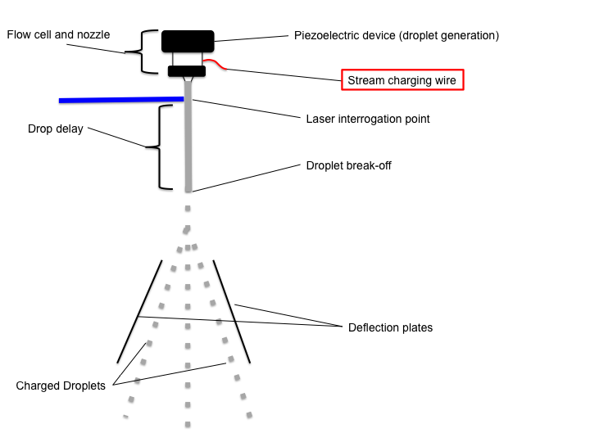

Cell preparation – in depth
Depending on the cell preparation method there could be significant cell death and debris which will impact the quality of the sort. For cells grown on plastic try to avoid mechanical scraping which usually results in a large proportion of dead cells, debris and clumps. “Difficult to remove cells” can be grown on low adherence tissue culture plates and polypropylene tubes should be used instead of polystyrene with round instead of conical bottoms. Adherent cells are commonly treated with trypsin but trypsin at high concentrations or over too long a period can damage cell membranes, impair antibody detection and kill cells. Trypsin inhibitors like Soybean trypsin inhibitor are better than serum since serum adds back divalent cations that facilitate cell adhesion and aggregation. EDTA can be added as a divalent cation chelator to reduce clumping. Furthermore, use of Accutase or Accumax can help reduce clumps.
Centrifugation should be of minimum duration and cells should not remain in pelleted state. Use swinging-bucket rotors as opposed to “fixed angle” rotors to prevent cell loss due to cells being deposited on the sides of the tube rather than the bottom. Remove supernatant by pouring rather than through suction to minimize chance of cell loss and disaggregate cells in pellet before re- suspending.
Clumps will clog the cell sorter; therefore filter the cells just prior to sorting since cells can re-clump over time. Options include a 70um cell strainer (Falcon 352350) for lager cells or a 45 um strainer (Falcon 352235).
Dead cells can have high autofluorescence and bind antibodies non-specifically therefore a viability dye should be included in the staining panel to gate out dead cells during sorting. Dead cells can also release DNA which enhances cell clumping. Consider DNAse 1 treatment- 200ug/ml DNase + 5mM MgCl2 in HBSS 15 – 30 min RT. Cells should be washed in the presence of 5mMMgCl2/HBSS and re-suspend in staining buffer containing 5mM MgCl2 with 25-50ug/ml DNase. Furthermore, to minimize cell death consider HBSS or culture media without phenol red. Addition of 2%BSA or FBS and 25mm HEPES buffer can also help.
Consider using magnetic bead enrichment or density gradient centrifugation to increase purity and decrease sort times and improve rare cell sorting.
Be realistic about how many cells will be lost during preparation to estimate the number of cells required to sort the target population(s). This will also be impacted by sort efficiency which is affected by many factors such as cell size, type, death and concentration. In practice dim and or cultured cells tend to have lower efficiency than bright primary cells such as lymphocytes. Preliminary analysis in advance of sorting can help establish sort efficiency and potential yield. Consider running the cells on the ImageStream Imaging flow cytometer to evaluate the cell preparation with respect to cell aggregates as well as specificity of stain prior to sorting.
Culture media is not an ideal sort buffer since the high pressure increases the partial pressure of CO2 resulting in lower pH. Use a buffer with strong pH buffering capacity like HEPES (25mM).This is especially important for sorts into micro-well plates. Furthermore, the phenol red in media can introduce a fluorescent background while the high protein content can adversely affect light scatter. Re-suspend the cells in a low protein buffer such as Ca++/Mg++ Free PBS or HBSS (0.5-2% BSA or up to 2% FBS) 25mM HEPES pH7.0.
To help reduce clumping
1mM EDTA up to a maximum of 5mM to prevent macrophages and monocytes from sticking to tubing. Note serum will negate function of EDTA.
or
10u/ml DNase especially if there are a lot of dead cells present.
DNase should not be used with EDTA because EDTA chelates the ions required for DNase function!

Cell concentration should be in the range of 10-20 X10^6 cells/ml and if you have fewer than 5X10^6 cells re-suspend the cells in a volume of 300ul. These are general guidelines and the concentration may need to be adjusted so bring extra buffer.
Fluorchrome choice
Generally speaking weak separation between populations will impact sort efficiency so aim to design a panel with the best separation possible. Use titrated reagents to add sufficient antibody to saturate all of the epitopes while avoiding excess antibody that will increase the potential for non-specific binding. For more information on how to perform antibody titrations consult LTRI flow cytometry core staff or visit the resource section of our website. Consult our website for guidelines on panel design or talk to the LTRI core staff for options.
Panel design tips
1. The biological question dictates panel design.
2. Assess antigens required and fluorchrome combinations available.
3. Lasers, detectors and filters available
Which detectors are most sensitive – reserve for important, unknown or low expression
Least sensitive – highly expressed markers
4. Classify antigens
Primary/major markers –highly expressed major subsets like CD4
Secondary markers – variable expression - subsets like CD45
Tertiary or unknown markers like CD25, EpCAM
Detectors for viability dye and a “dump” channel (for e.g. a lin neg subset) if necessary
5. Reduce the amount of spectral overlap especially into detectors reserved for dim markers
6. Use FC blocker (anti-CD32/16, Human FC block) if appropriate
7. Include a viability dye in your panel to allow for dead cell exclusion even if you are only interested in RNA. Many choices are available to work with your panel. Good sources are Invitrogen and Biolegend.
8. Panel design tools like Flurofinder have links to vendor websites which will aid you in design of a panel. FluroFinder https://flurofinder.com. Look for our institution and identify the instrument you want to use. Check your panel spectrum viewers to see if it can be improved and adjust panel if necessary.
Spectrum viewers - BD biosciences, Thermo fisher/Invitrogen, Biolegend, Chromocyte

Controls
Controls are necessary for setting PMT voltages, compensation, and regions to identify the population of interest.
Unstained and single stained controls
Unstained controls help identify the auto-fluorescent background while single stained controls are necessary for establishing the compensation values for your panel. Rules of thumb for single stained controls are:
1. One single stained control for each fluorchrome.
2. Each single stained control must be as bright as or brighter than the same stain within the sample.
3. Each single stained control must have a negatively stained component that is spectrally matched (i.e. same autofluorescence).
4. Compensation is a property of the fluorchrome not the carrier. Therefore consider antibody capture beads or a different cell type with good expression of the epitope(s) in question for performing compensation.
Fluorescence minus One Control(s) (FMO)
FMO controls are gating controls used to establish gates between positive and negative staining for a fluorchrome of interest. They contain all of the fluorchromes from a panel except the one of interest. Combining all of the fluorchromes except the one being measured will allow regions to be drawn that take into account of a phenomenon referred to as measurement error. This can be critical for sorting populations with small changes in fluorescence especially if using a panel for the first time! Ask the LTRI flow core staff for more details about this important control.
Biological Controls
Positive and negative biological controls if available are also very useful for establishing sort regions.
Collection media
Options
PBS-/- 10-50%FBS
Culture media
PBS
Lysis buffer from RNA isolation kit
Collection tubes should be 1/3 full with collection media
Tubes should be sterile and RNase free for RNA collection. For recovery of live cells pre-coat the tubes with 1%BSA to keep cells from sticking to the sides of the tube by filling the tubes with PBS 1%BSA for 30 minutes prior to sorting. For western blotting you may want to avoid adding an external protein.
Transport the samples in an ice container with a lid. BSLII transport follows “transportation of dangerous goods guidelines” Essentially this means that samples are carried in a sealed primary tube such as a microfuge tube within a sealed secondary container such as a Styrofoam container.
Don’t forget the biosafety form.
Determining the number of cells to begin sort with.
Approximations of the starting cell number to sort 100,00 cells. The frequency of the population, the recovery from the sorter, and recovery from sample processing factor into how many cells are required at the start of the experiment. The time to sort is an estimate of how long it would take to sort the cells at different nozzle sizes (which relates to how fast the sorter can run, and thus the droplet generation frequency).
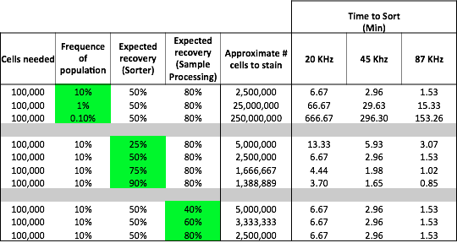

Annie's recommendations
Here are notes about how to prepare your samples for cell sorting:

1. Cell concentration (before sort) should be about 2 – 5 million per mL. All samples must be filtered (minimum 40 micron pore) before sorting.

2. Bring extra sort sample buffer. Optimal buffer in which to bring your cells, although some variation is acceptable:
1 x Phosphate Buffered Saline (PBS) or Hanks Balanced Salt Solution (HBSS) (Ca2+/ Mg2+ Free)
25 mM HEPES pH7.0
1% Fetal Calf Serum (Heat inactivated) or 1% Albumin (for sticky cells)

3. For samples with a high dead cell concentration or primary tissue preps: Dead cells can release their DNA into sorting media which in turn can cause cells to clump together. Adding DNAse I in the presence of MgCl₂ will help reduce the aggregation.
a. Treat cells for 15-30 minutes in a sterile solution of 100 ug/mL DNAse I and 5 mM MgCl₂ in HBSS at room temp.
b. Wash the cells 1x in HBSS containing 5mM MgCl₂.
c. Resuspend the cells in HBSS containing 25-50 ug/mL DNAse I, plus at least 1mM MgCl₂ prior to and during the sort. (5mM MgCl₂ is optimal)

4. For bulk collection, bring media with a high FBS content (~50%) to help cells recover from the sorting process.
a. For direct plate collection, bring plates loaded with the culture media appropriate for the sorted cells.
b. For post sort mRNA analysis, cells can be sorted directly into RNA isolation reagents, such as Trizol-LS, RTL buffer, RNA Later, etc. Please ask for more details.

